Computer Network 1
Lab 2
Network tools in Windows and Linux

Student Name:

Student No.:

I. Objectives
- Know how to configure TCP/IP in Microsoft Windows and Linux operating systems.
- Know common networking tools.
II. Contents
1. Configuration of TCP/IP in Microsoft Windows

1. Configuration parameters of TCP/IP
- Use ipconfig to look for TCP/IP configuration details
- There are commonly two Adapters (Network Interface Card and PPP)
- Note down configuration of Network Interface Card:
IP Address: Subnet Mask:
Default Gateway: DNS Server:

2. Configure TCP/IP: automatic IP or manual
- Start -> Settings -> Control Panel -> Network Connections -> Local Area Connection -> Properties -> Internet Protocol (TCP/IP) -> Properties
2. Configuration of TCP/IP in Linux
- Look into the network configuration file /etc/sysconfig/networking/devices/ifcfg-eth0. Information in file /etc/sysconfig/networking/devices/ifcfg-eth0 is used to configure TCP/IP parameters for the first NIC.
- If there is any change about TCP/IP configuration, change the configuration parameters in /etc/sysconfig/ifcfg-ethx, the, use the following command to restart network service:
# service network restart
3. Learn basic network commands

1. ipconfig (ifconfig in Linux/UNIX)
- System administrator uses this command to examine TCP/IP configuration parameters and also to configure parameters for network interfaces:
- Detail basic syntax of ipconfig/ifconfig:
USAGE:
ipconfig [/allcompartments] [/? | /all |
/renew [adapter] | /release [adapter] |
/renew6 [adapter] | /release6 [adapter] |
/flushdns | /displaydns | /registerdns |
/showclassid adapter |
/setclassid adapter [classid] |
/showclassid6 adapter |
/setclassid6 adapter [classid]]
Where:
adapter Connection name
(wildcard characters * and ? allowed, see examples)

Options:
/? Display this help message
/all Display full configuration information.
/release Release the IPv4 address for the specified adapter.
/release6 Release the IPv6 address for the specified adapter.
/renew Renew the IPv4 address for the specified adapter.
/renew6 Renew the IPv6 address for the specified adapter.
/flushdns Purges the DNS Resolver cache.
/registerdns Refreshes all DHCP leases and re-registers DNS names
/displaydns Display the contents of the DNS Resolver Cache.
/showclassid Displays all the dhcp class IDs allowed for adapter.
/setclassid Modifies the dhcp class id.
/showclassid6 Displays all the IPv6 DHCP class IDs allowed for adapter.
/setclassid6 Modifies the IPv6 DHCP class id.
+For Release and Renew, if no adapter name is specified, then the IP address
leases for all adapters bound to TCP/IP will be released or renewed.
+For Setclassid and Setclassid6, if no ClassId is specified, then the ClassId is removed.
+Used without parameters, ipconfig displays Internet Protocol version 4 (IPv4) and IPv6 addresses, subnet mask, and default gateway for all adapters.

Examples:
> ipconfig ... Show information
> ipconfig /all ... Show detailed information
> ipconfig /renew ... renew all adapters
> ipconfig /renew EL* ... renew any connection that has its
name starting with EL
> ipconfig /release *Con* ... release all matching connections,
eg. "Wired Ethernet Connection 1" or
"Wired Ethernet Connection 2"
> ipconfig /allcompartments ... Show information about all
compartments
> ipconfig /allcompartments /all ... Show detailed information about all
compartments

2. netstat
- This command is used to examine information about network connections of the computer and TCP/IP protocols.
- Provide the result when run the command “netstat –a”:
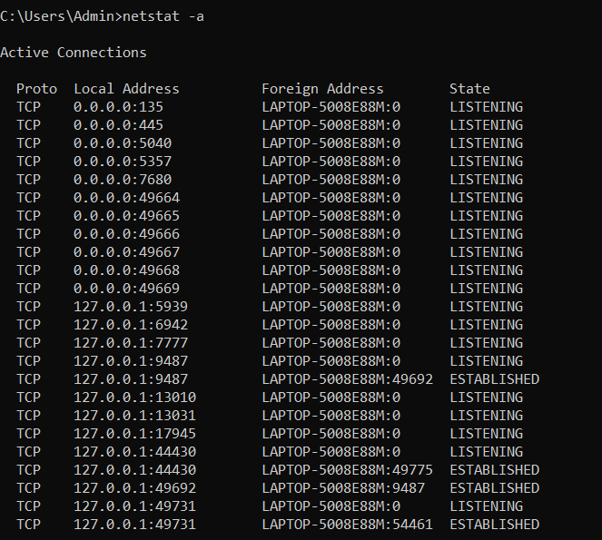

3. tracert (traceroute in Linux/UNIX)
- This command is used to trace a route to a computer in the network. It is usually used to investigate network connections when problems happen.
- Provide the result when run: “tracert www.google.com”:
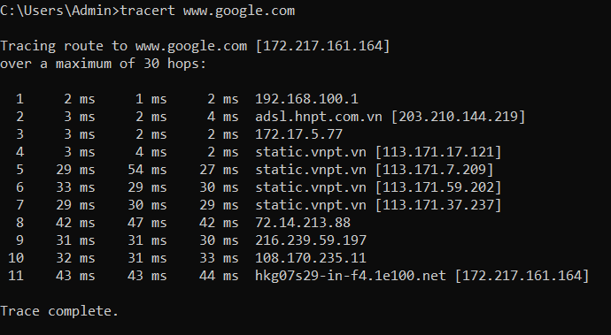

4. route
- Route command is used to examine, add or remove a route in routing table of a computer.
- Provide the result when rung “route PRINT”:
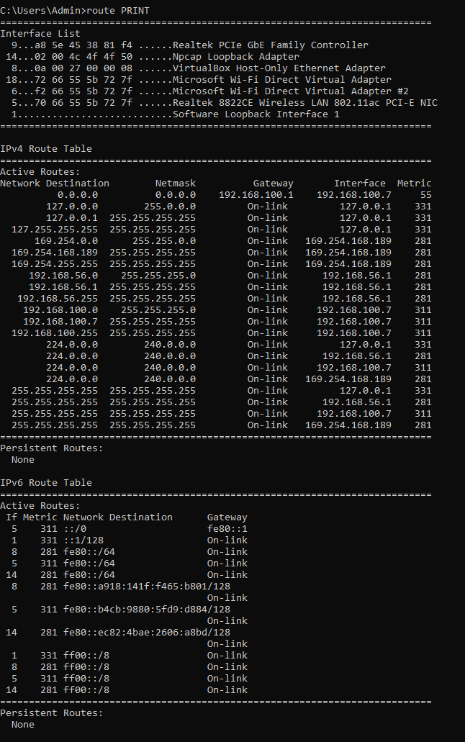

5. ping
- Ping command is used to check if a host in the network is reachable:
- Provide the result when run “ping www.cse.hcmut.edu.vn”

6. nslookup
- nslookup command is used to interact with Domain Name Systems002E
- Use nslookup to get IP address of www.vnn.vn (nslookup www.vnn.vn):
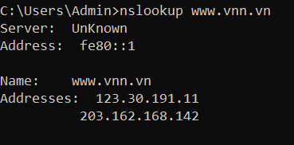
- Get IP address of Mail eXchange domain hotmail.com (nslookup -type=MX hotmail.com)

7. SSH (Secure Shell) Client
- SSH client is used for login securely to a remote server.
- Use Google to search for common SSH client on available on the web:
+ PuTTY
+ MobaXterm

